### fruit finder using color thresholds and morphology

*Yuankai Wang, Chen Yin*

Department of Computer Science, Rose-Hulman Institute of Technology   
{wangy16, yinc}@rose-hulman.edu

#### Abstract

Finding fruit in a picture is an interesting thing, and it is helpful for further learning in image recognition. We developed a system based on color thresholds and morphology to recognize fruit in the picture. It can accurately find apples, bananas, and oranges in the image most of the time. Building the model requires much work on finding the suitable color threshold and the way of morphology, but it can work easily after we find the constants. We set a group of thresholds for each fruit to be more accurate. In three pictures with reasonable overlap, we can recognize 94.9% of the fruits correctly. We will also get the sizes and center points of the fruit. In pictures with much overlap, we can recognize the place of the fruits correct.

**1. Introduction**

Finding fruit in a picture is an interesting and difficult problem. With a picture full of fruit all around, we can use this method to immediately figure out how many apples, oranges, and bananas there are. This is a widely discussed topic and many people had made some progress on this. This is a good project for people who just began learning image recognition to have a better understanding of the field. We used the methods we learn in class into a real project and found some exciting results. This is the basis for further learning in this field and the ideas and methods we use in this project can be useful for other work. The whole working process is quite interesting. In this project, we are going to recognize the fruit in the pictures in Figure 1.

C:\Users\Administrator\Documents\Classes\SO2\CSSE463\Project\Fruit Finder\fruit\mixed_fruit1.tiffC:\Users\Administrator\Documents\Classes\SO2\CSSE463\Project\Fruit Finder\fruit\mixed_fruit2.tiffC:\Users\Administrator\Documents\Classes\SO2\CSSE463\Project\Fruit Finder\fruit\mixed_fruit3.tiffC:\Users\Administrator\Documents\Classes\SO2\CSSE463\Project\Fruit Finder\fruit\fruit_tray_crop.tiff

**Figure 1**: Four pictures of fruits in different situations.

However, the project is not easy. Some usual ways of dealing with the problems are to use a neural network. However, this one needs more test cases and more work that is difficult. From our observation, we found that color is the obvious difference. Therefore, we decided that we could easily found these fruits by using different selection criteria on the fruit. The color of the fruit has some variation under different conditions. The size of the fruit may differ. Some of the fruit will overlap. Some of them may even just show a little part out. This is easy for human to see it, but difficult for the computer to recognize it. When these two factors are combined, for example, a group of the same kind of fruit is put together. We can hardly tell the border of each individual fruit. Therefore, this project is quite challenging.

We first used some pictures of the same kind of fruit but under different light conditions to try to find a good range of color to identify the color threshold we want. We found only one kind of fruit each time and combined the masks together to form the final picture. Then we dilated first to remove the noise in the background and eroded the rough shape of the fruit back to make the mask better. Using this method can both make the fruit mask more comprehensive and clean up the noise in other parts of the picture. To compare which color we did not include in our mask, we cover the mask back to the original picture, and compare them. Therefore, we can make sure that most of the part we wanted are masked and one single fruit is a connected object. Then we used a Matlab method to count the number of objects we found. After we felt we had a good understanding and technique of the problem, we tried this on more complicated pictures.

When we worked on pictures with different kinds of fruits, the main difference between this and previous works is that we need to deal with the similar colors on different fruit. We used a more detailed threshold to work on that. After many tests, we decided some morphology method for different fruit, according to the quality of the raw mask we get. The method was unchanged for all the pictures. The quality was the best when they had no overlap, and became worse when they had more overlap. But the overall quality was almost all correct. Therefore, we got the number of each fruit from the masks. Then we calculated their sizes and centroids.

**2. methodology**

Now we will show our method to find the fruit. The method we used for each picture is the same. Therefore, we can make sure this method can apply to different pictures.

**2.1 Find color thresholds**

Because we were looking for the same color, we believed that looking at hues is an effective way. Therefore, we first turned the RGB colors into HSV format. Then we looked into the picture to find its values. By looking at them, we found out that even though they look almost in the same color, some of the parts were quite different such as the values of S(saturation) and V(value). To include all these pixels, without adding lots of noise into it, we made several thresholds to handle different colors of the fruits. In some pictures, they had some black background color. To remove the black parts, we created a threshold which h=0, s=0 and v=0 and set the pixels that satisfy this condition to be white. Because the color was quite similar to the dark part of apples, we just removed the black color pixels. Although we still had noises there, we expected these noise would be removed by morphological operation later. The thresholds of HSV for apples, bananas, and oranges are shown in the following tables.

**Table 1:** Threshold for apples

(D means discard, No D means keep)

|  |  |  |  |  |  |  |  |
| --- | --- | --- | --- | --- | --- | --- | --- |
|  |  |  |  |  |  | D | D |
| H | 0.0~0.3 | 0.94~1.0 | 0.0~0.08 | 0.0~0.08 | 0.9~1.0 | 0 | 0.0~0.2 |
| S | 0.8~1.0 | 0.45~1.0 | 0.5~1.0 | 0.0~0.31 | 0.3~1.0 | 0 | 0.0~0.11 |
| V | 0.0~0.3 | 0.1~0.5 | 0.0~0.55 | 0.0~0.55 | 0.0~0.55 | 0 | 0.0~1.0 |

**Table 2:** Threshold for bananas

|  |  |  |
| --- | --- | --- |
| H | 0.15~0.2 | 0.11~0.21 |
| S | 0.79~1.0 | 0.6~0.95 |
| V | 0.4~0.55 | 0.6~1.0 |

**Table 3**: Threshold for oranges

|  |  |  |  |
| --- | --- | --- | --- |
| H | 0.0~0.11 | 0.0~0.11 | 0.11~0.14 |
| S | 0.7~1.0 | 0.78~1.0 | 0.7~0.85 |
| V | 0.7~1.0 | 0.4~1.0 | 0.5~0.6 |

We found out that some of the dark background colors were quite similar to the color of our apples in some parts. We first made the dark colors to be white. Then we tested and rewrote our filters for apples until we found a proper way to cover most of them. We set our mask to be all 1’s and set our apples to be 0’s on the mask. The result of our mask after setting color thresholds are in Figure 2.

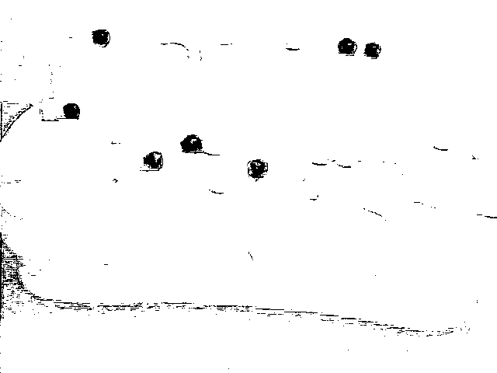

**Figure 2:** The mask of apples for the first image (no overlapping) before any morphology methods.

**2.2 Morphology methods**

From Figure 2, we can see that there were lots of noise in the background. For example, the outline of the couch was obvious. There were also some holes inside the “apples”. First, we wanted to ensure that our count of objects is correct, so we tried to remove all the non-apple black parts. To avoid recognizing those noises to be the fruit we want, we chose to dilate it first. Because some of the black parts had a relatively high density of the points, we used a large square with size 9 to dilate. The effect after the dilation is shown in Figure 3.



**Figure 3:** The mask of apples for the first image after dilate with a 9\*9 square.

Figure 3 really removes many things from the original mask. We cleaned up everything we did not want, but we still threw away many parts that should be the part of apples. We believed that these remaining parts are truly apples, so we can build the apples back by eroding it with a large square. After several different tests, we found out that a square of 13\*13 is the best size to erode. The effect after the erosion is shown in Figure 4.

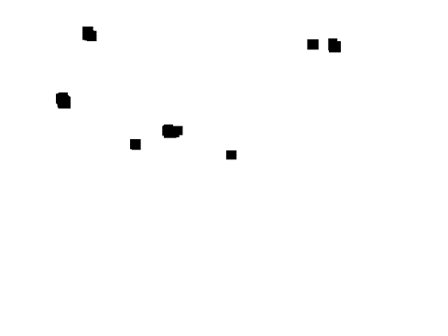

**Figure 4:** The mask of apples for the first image after first dilating with a 9\*9 square then eroding with a 13\*13 square.

Figure 4 gives a quite accurate shape of the apples with no noise at background or holes inside the objects. Then we worked on banana and orange in the same method. Since the color information of them was different, the quality of our raw mask after setting color thresholds has some difference. Therefore, the sizes of morphology methods are different on different fruit. Figure 5, 6 and 7 are for bananas and Figure 8, 9 and 10 are for oranges.

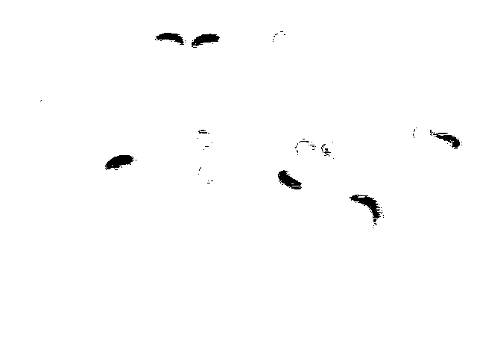

**Figure 5:** The mask of bananas for the first image (no overlapping) before any morphology methods.

Since the HSV value for the color of bananas and oranges are quite similar, we can see some of the oranges have some outlines in the pictures.

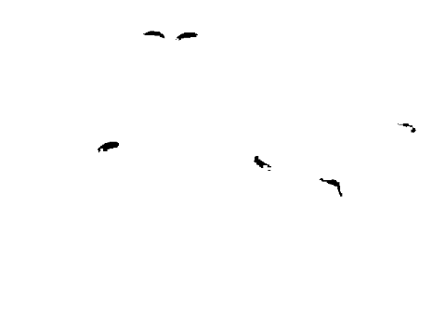

**Figure 6:** The mask of bananas for the first image after dilate with a 5\*5 square.

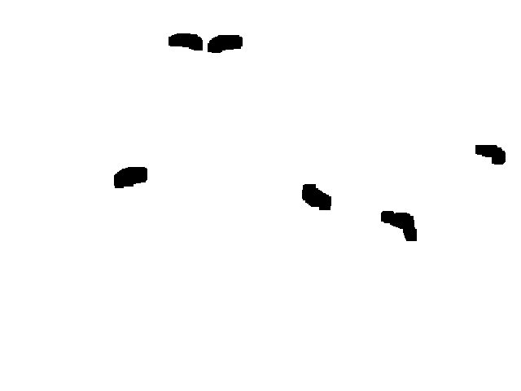

**Figure 7:** The mask of bananas for the first image after first dilate with a 5\*5 square then erode with an 11\*11 square. Since the bananas are not that large, we used a smaller square than apples’.

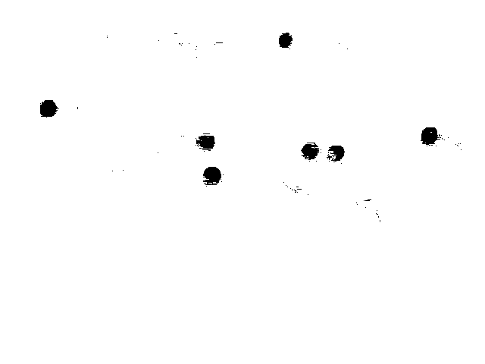

**Figure 8**: The mask of oranges for the first image (no overlapping) before any morphology methods.

We felt that set the threshold for orange is harder than the previous two, because its color is between them, any slight difference will result in showing many other things. The outline of the couch and some bananas are there.

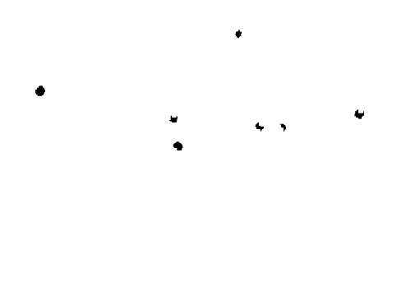

**Figure 9**: The mask of oranges for the first image after dilate with a 7\*7 square. This is the same idea as we did for the apples.

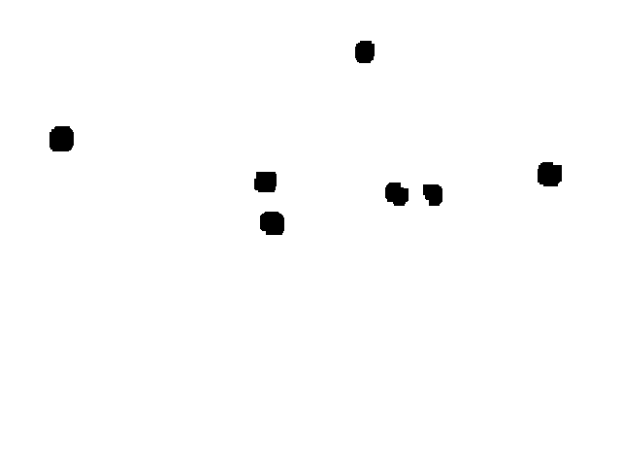

**Figure 10**: The mask of oranges for the first image after first dilate with a 7\*7 square then erode with an 11\*11 square.

**2.3 Final image**

After we got masks for all three kinds of fruit, we needed to put them together. Since we were using 1 as background and 0 as the fruit we recognized, we first switched the 0’s and 1’s. To make the fruit to be 1 on the matrix and the background to be 0. Then we assigned them to different colors in HSV format to show the difference. To put them together, we only needed to dot product them.

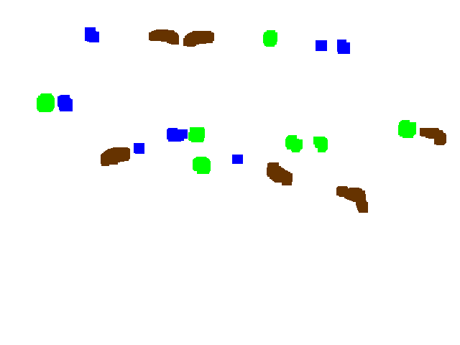

**Figure 11**: The picture shows the final mask. To make it clear, we did not use the color that they should be. In the picture, apples are blue, bananas are brown and oranges are green.

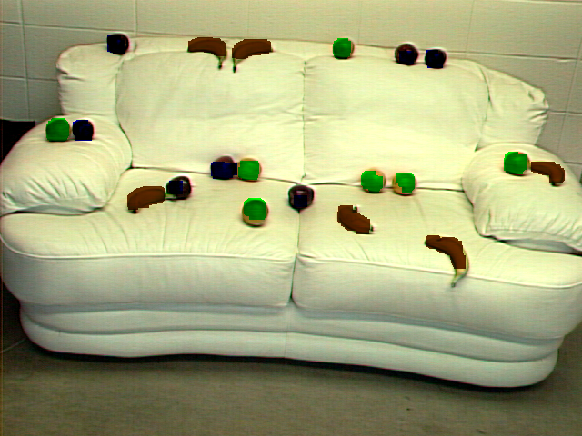

**Figure 12**: This is the picture when we apply our mask to the original picture. It fits well.

**2.4 Other images**

For the second picture, the overall idea was the same. We just used the same code to run it and the results are quite accurate.

Pictures in Figure 13 to Figure 16 are the images we get from the second picture. The size of our dilation methods keeps the same for each fruit. Because there are some overlaps in the fruits, it is more difficult for our thresholds to tell the difference.

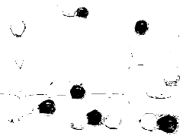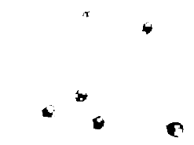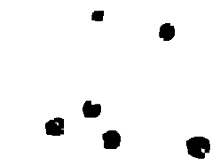

**Figure 13:** Raw apple image, apple mask after dilation, and apple mask after erosion

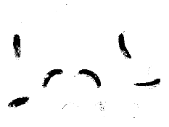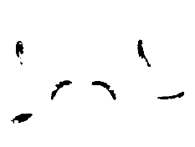 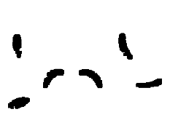

**Figure 14:** Raw banana image, banana mask after dilation, and banana mask after erosion

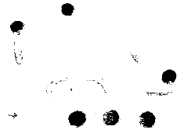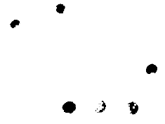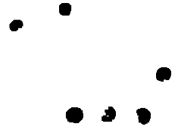

**Figure 15:** Raw orange image, orange mask after dilation and orange mask after erosion in sequence.

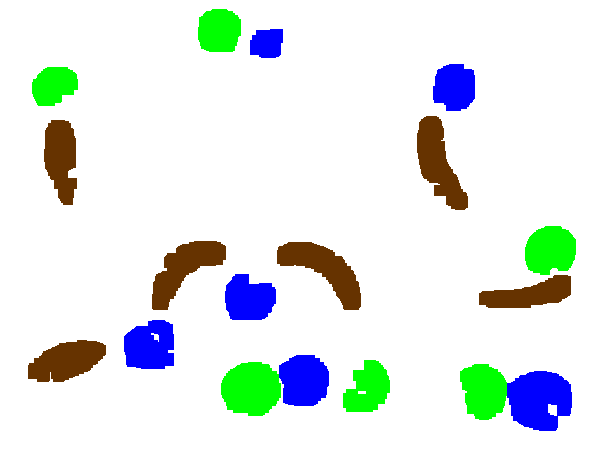

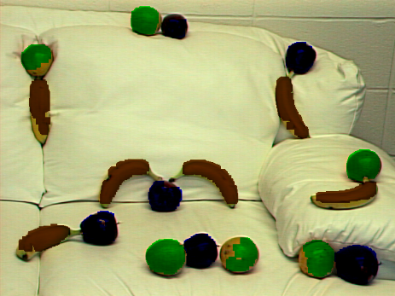

**Figure 16:** Final mask and the mask with background

For the third picture, we still used the same way. The figures of picture 3 as listed below.

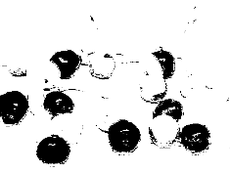 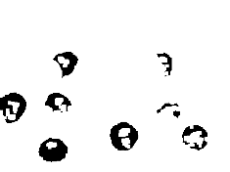 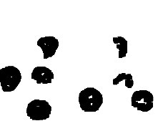

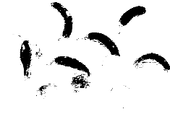 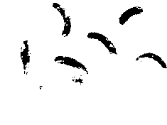 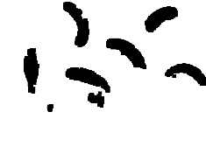

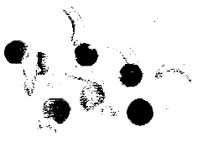 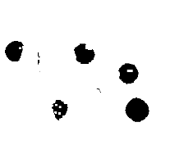 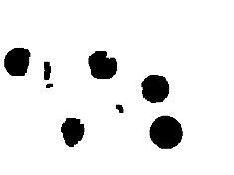

**Figure 17:** fruit with raw, dilated, eroded masks

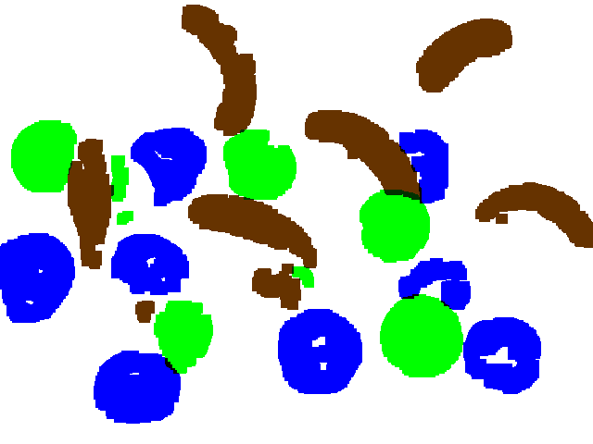 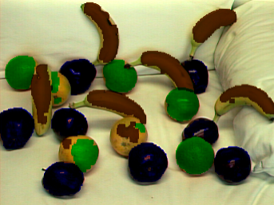

**Figure 18:** Final mask and the mask with background

Since the fruit in picture 4 is so close that we can hardly find them as individual correctly. We can get the general size of the fruit but cannot really differ the bounder of each fruit. The figures of tray are shown in Figure 19.

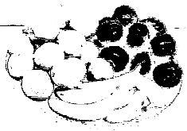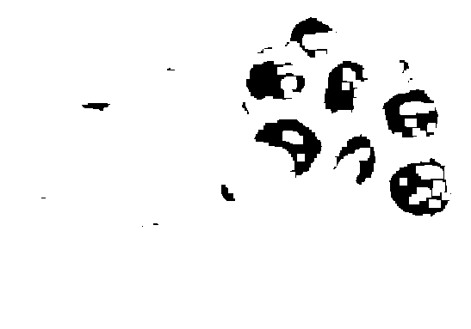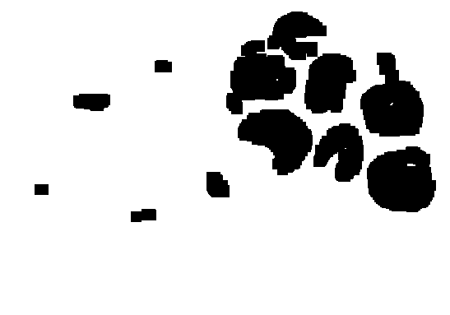

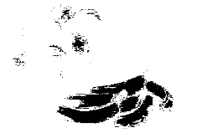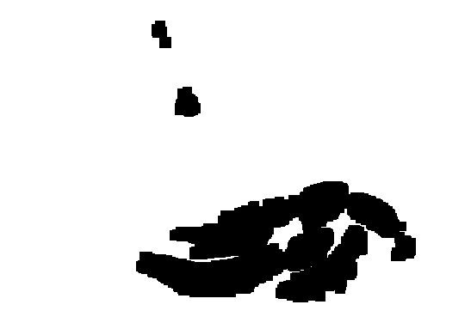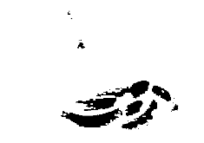

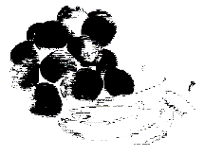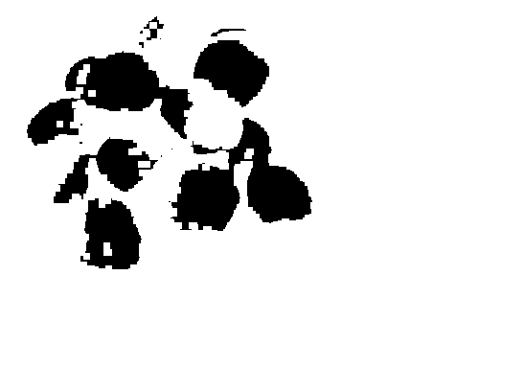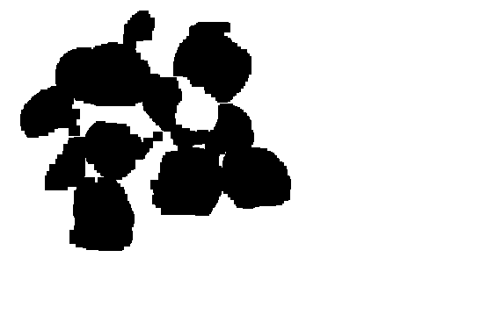

**Figure 19:** In the fruit tray, apples, bananas, and oranges with raw, dilated, eroded masks.

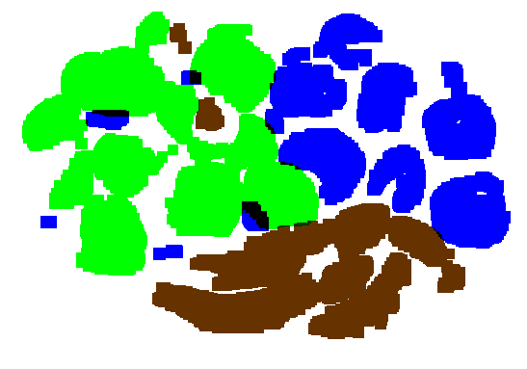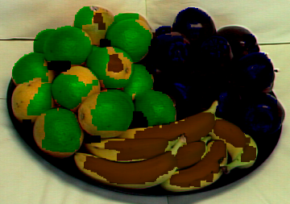

**Figure 20:** Final mask and with the background.

When all the fruit was together, the shadows of the fruit affected the color of the fruit. So some of the parts in one fruit may have the same color as the other kind of fruit. When it overlapped, the masks were connected together. So when we tried to count according to the connected components, it would treat them all as one fruit. Therefore, the result is not as good as previous pictures.

**3. Results**

**3.1 Data**

We used four pictures shown in Figure 1 to test our model. The data we got is quite accurate. For the first picture, we got the correct number of fruit and they are all at the proper place with a proper size. The data is listed in Table 4.

**Table 4**: The size and centroid information in pic 1

|  |  |  |
| --- | --- | --- |
|  | size | centroid (row, column) |
| apple1 | 441 | (144.2744,91.0249) |
| apple2 | 382 | (49.3482,128.1021) |
| apple3 | 223 | (206.9372,194.0583) |
| apple4 | 490 | (188.0612,246.2694) |
| apple5 | 195 | (222.0000,331.0000) |
| apple6 | 240 | (64.0000,447.5000) |
| apple7 | 337 | (65.8991,478.1899) |
| banana1 | 849 | (217.7727,160.6784) |
| banana2 | 689 | (51.2816,229.6328) |
| banana3 | 757 | (53.8587,276.6764) |
| banana4 | 804 | (242.9789,388.9055) |
| banana5 | 931 | (274.8539,493.6069) |
| banana6 | 618 | (188.8301,604.7686) |
| orange1 | 591 | (143.7597,63.9983) |
| orange2 | 450 | (187.9311,274.2800) |
| orange3 | 537 | (230.4711,281.2477) |
| orange4 | 410 | (54.0220,376.5293) |
| orange5 | 464 | (200.4784,409.3599) |
| orange6 | 375 | (200.6587,477.0187) |
| orange7 | 550 | (180.1800,566.8655) |

We successfully found all the fruit in the picture. There are 7 apples, 7 oranges, and 6 bananas in the picture and we found all of them in the right place. Since it does not overlap, we can recognized different fruit in a good quality. We have a good morphology method, which dilates and then erodes. We do both steps with large squares, so we can throw away all the things we do not want to have and extend the parts we want back.

Our result for picture 2 is shown below.

**Table 5**: The size and centroid information in pic 2

|  |  |  |
| --- | --- | --- |
|  | size | centroid (row, column) |
| apple1 | 2389 | (370.3797,161.3370) |
| apple2 | 2098 | (320.1439,266.7011) |
| apple3 | 1017 | (47.1563,284.3137) |
| apple4 | 2425 | (407.3662,325.0825) |
| apple5 | 1872 | (93.8542,486.3584) |
| apple6 | 3476 | (428.1766,577.1484) |
| banana1 | 2544 | (386.3640,71.7869) |
| banana2 | 2404 | (169.7571,65.8037) |
| banana3 | 2730 | (287.8736,197.3264) |
| banana4 | 2894 | (288.6406,347.1804) |
| banana5 | 2804 | (175.2397,469.2293) |
| banana6 | 2109 | (315.2907,566.1053) |
| orange1 | 1575 | (92.0775,58.0127) |
| orange2 | 1797 | (33.6422,234.7746) |
| orange3 | 2971 | (416.3363,268.9519) |
| orange4 | 1959 | (415.7534,393.6585) |
| orange5 | 2360 | (418.4678,517.6000) |
| orange6 | 2290 | (268.2900,588.3965) |

In picture 2, we also did it all correct. There are 6 apples, 6 oranges and 6 bananas in the image. The quality of our masks went down, but it can still give a good count.

Our result for picture 3 is shown below.

**Table 6**: The size and centroid information in pic 3

|  |  |  |
| --- | --- | --- |
|  | size | centroid (row, column) |
| apple1 | 6382 | (299.4804,38.1769) |
| apple2 | 6027 | (419.7515,148.3262) |
| apple3 | 4376 | (286.9676,162.6284) |
| apple4 | 4769 | (175.7943,185.0224) |
| apple5 | 6669 | (381.0529,344.9681) |
| apple6 | 2706 | (305.4741,474.1179) |
| apple7 | 2899 | (176.3294,462.7206) |
| apple8 | 5269 | (383.4232,543.8994) |
| banana1 | 4823 | (216.8204, 98.0039) |
| banana2 | 423 | (336.6974, 156.8534) |
| banana3 | 5354 | (74.3298, 244.2400) |
| banana4 | 5326 | (242.7828, 273.1694) |
| banana5 | 1740 | (309.7299, 301.1833) |
| banana6 | 5528 | (161.5300, 396.8746) |
| banana7 | 4639 | (56.1625, 498.2153) |
| banana8 | 4292 | (227.3779, 583.5899) |
| orange1 | 4499 | (169.1343, 48.0645) |
| orange2 | 814 | (193.2494, 129.0786) |
| orange3 | 232 | (235.7888, 135.2716) |
| orange4 | 3734 | (361.9108, 198.3747) |
| orange5 | 4694 | (179.9018, 279.6892) |
| orange6 | 397 | (298.8035, 328.5945) |
| orange7 | 4871 | (244.1154, 426.3823) |
| orange8 | 6364 | (364.3011, 455.6317) |

In picture 3, we still had a high correction rate. There are 8 apples, 7 oranges, and 6 bananas. We found one more orange and two more bananas. This is because that one part of an orange was recognized as a banana and that orange split into two parts when we recognized oranges. The other orange also had a part that has a quite a large part has color in our threshold for bananas. We failed to differ them, and got the error.

Our result for the tray is shown below.

**Table 7**: The size and centroid information in tray

|  |  |  |
| --- | --- | --- |
|  | size | centroid (row, column) |
| apple1 | 221 | (231,51) |
| apple2 | 831 | (124.201,112.3538) |
| apple3 | 455 | (262.3802,174.9495) |
| apple4 | 303 | (81.2607,198.7987) |
| apple5 | 743 | (225.9542,264.5209) |
| apple6 | 4780 | (94.8728,315.5366) |
| apple7 | 4676 | (167.5115,339.3963) |
| apple8 | 6407 | (75.8928,382.9549) |
| apple9 | 3044 | (184.1127,415.5003) |
| apple10 | 5111 | (126.1141,477.1156) |
| apple11 | 5512 | (219.5067,489.8589) |
| banana1 | 25101 | (287.3838,325.9935) |
| banana2 | 501 | (40.3613,187.996) |
| banana3 | 825 | (120.5636,217.7358) |
| orange1 | 25321 | (146.0387,185.6157) |
| orange2 | 10829 | (210.1878,114.6663) |
| orange3 | 5608 | (70.143,242.936) |

In the tray, our counted number has a large difference with the actual number. We counted the fruit that shows part of it in the image manually, there are 10 apples, 15 oranges, and 6 bananas. We got 11 apples, 3 oranges, and 3 bananas. We can see from the table that the sizes have large differences between them. This is because some of our fruits are connected and are recognized as one fruit. Some are extremely small because they are just the shadow of something, not a real fruit.

**3.2 Strength and weakness**

Our model of finding fruit has a high accuracy. This accuracy is based on our reasonable color thresholds and useful morphology method that cleaned up almost all of the noises. Although we used a square erosion to get the shape, it is still quite similar to what it should be. It gives a nice cover when we put it back to the original picture. We can deal with the images with some overlapped fruit.

There are also some points that need more improvement. It is quite risky if we dilate a large square and then erode it back. Because the dilation may throw away the parts we really need. Because our model is sensitive to lighting. A little change in the light may need us to reset the color thresholds. The adjustment for them is also a tiring job. Our model cannot handle the case where some fruit of the same kind is put together.

To deal with the weaknesses, we may try to use more, but smaller morphology methods. We may also use some other technique that works well on clean noises. We may make some changes to the picture first to form a more standard picture that can mostly fit into our default thresholds. For the overlap problem, we may improve it by detecting the edges between fruit.

**3.3 Next steps to take**

If we have more time for a short-term, we will include more methods on cleaning the noise. For example, using some more specific filters to clean the noise in the background. So we will have less information loss while we dilate with a large square. We may also include some edge detecting method so that we can differ from fruit to fruit when they overlap. We will also find more pictures and test them to improve our model. If the pictures have different light conditions, we will adjust it first to be the similar light condition as our testing pictures. We will include the adjustment method in it.

If we have more time for a long-term, we will try to use a more complicated and better way than the color threshold model. Maybe the neural network model will have a better performance. But we will still keep our work on the colors, since they may be helpful. We will also add some other fruit to it to make it more useful.

**4. conclusions**

With our fruit finder model, we can recognize the fruit in the image, and show their position, their size and the kinds of fruit they are. Our result is quite accurate with different size of the fruit and allows some overlap between them. The concept of this model can be applied to any other color recognition to objects with obvious different colors.